**Task 1**

# **Steps to complete your Git-hub and its Git Repository**

Step 1: Create a account in github. After that from the homepage of github click on the ‘Create a new repository’ option.

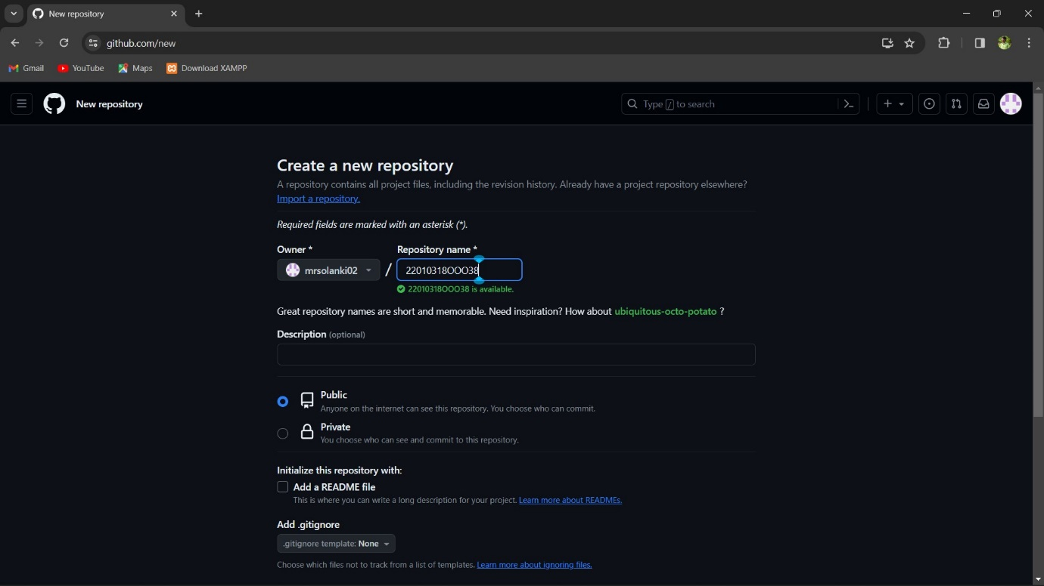

Step 2: Now in the next popped up window, write your repository name(22010318300038).

Thereafter, click on public option below (this will allow anyone on the internet to see this

repository). Now mark the ‘Add a README file’ option. After that click on

‘Create repository’ option.

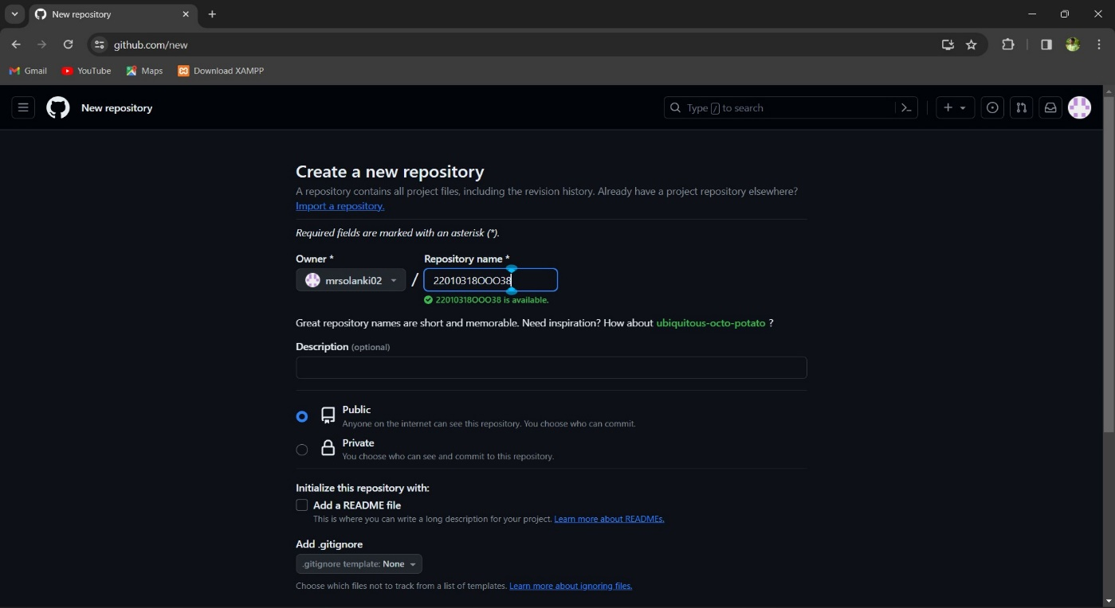

Step 3: A repository will be visible on your github account.

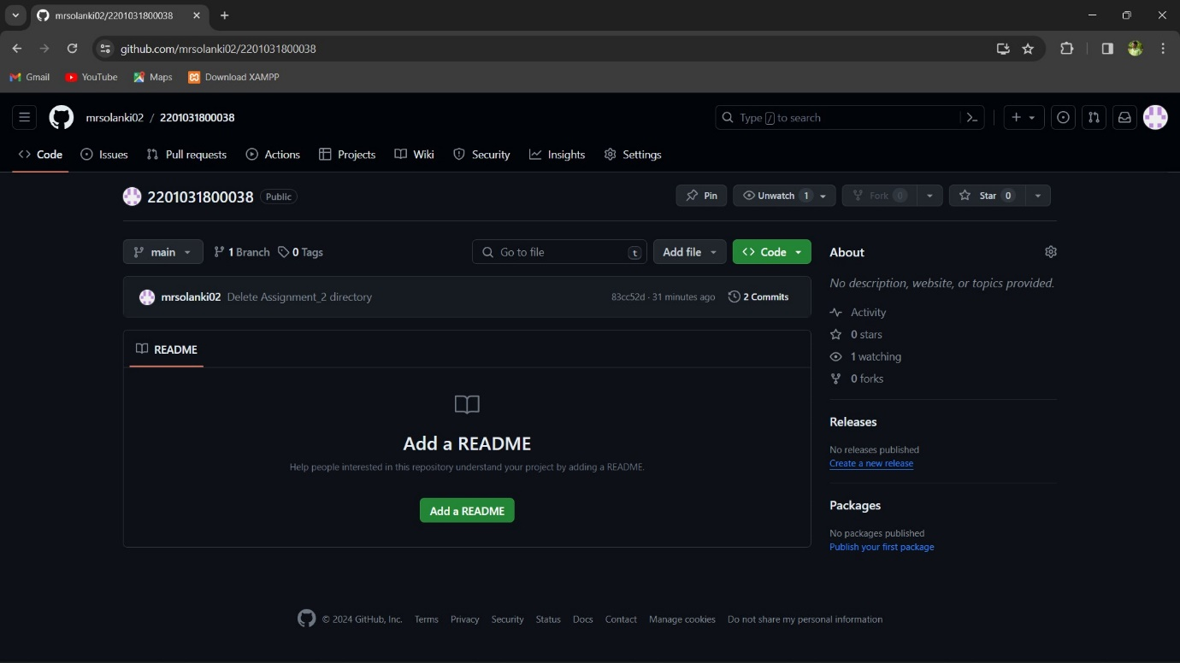

Step 4: Now click on ‘Add file’ option to create a folder in the repository. We are required to

create 2 folders here in our repository, named as ‘Assignment_1’ and ‘Assignment_2’.



Step 5: Write your folder name in the specified area(Assignment_1 and Assignment_2).

Step 6: Now move forward by clicking on ‘Commit changes..s’ option.

Step 7: Now write your commit message to show what changes you made in your project.

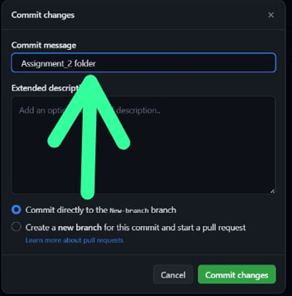

Step 8: Thereafter click on Commit changes option. Similarly create second folder as well.

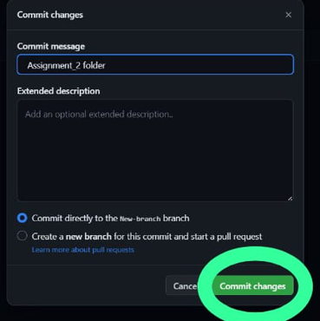

Step 9: Now you’ll be able to see two folders that you created in your repository.

